**LIBRARY MANAGEMENT SYSTEM FOR DATAMEX COLLEGE OF SAINT ADELINE VALENZUELA BRANCH**

Submitted by:

Ladia, Anthony

Junsay, Rjhay

Hondrado, Acezzel ann

Marabe, Uvert

Submitted to:

Mr. Gabriel Thomas Torneros

**PROJECT PROPOSAL**

**INTRODUCTION**

**Overview**

This project focuses on the modernization of the Library Management System for Datamex College of Saint Adeline Valenzuela Branch. The initiative aims to replace outdated, manual, or semi-digital processes with a system designed to help the Librarian. By leveraging modern technologies, the system will improve data accuracy and enhance user convenience. It will serve as a centralized hub for managing all library resources, including book inventory, borrower records, and catalog information, ensuring that the Librarian can easily access and manage essential library services.

The proposed system will also feature efficient tracking capabilities for borrowed and returned books, reducing the chances of misplaced records and human errors. Ultimately, this modernization project will not only improve operational efficiency but also create a more user-friendly and accessible library experience for the Datamex College of Saint Adeline Valenzuela Branch.

**Background**

The library currently lacks tools for the librarian to use and only relies on paper-based systems, an LMS will help reduce the workload of the librarian and improve the overall library service experience.

**Objectives and Goals**

* Reduce the workload of the librarian
* Provide an easy way to search for books and their availability
* Book tracking to easily track who borrowed a book
* Minimize human error

**CLIENT INFORMATION**

**Name of the Client**

Datamex College of Saint Adeline Valenzuela Branch

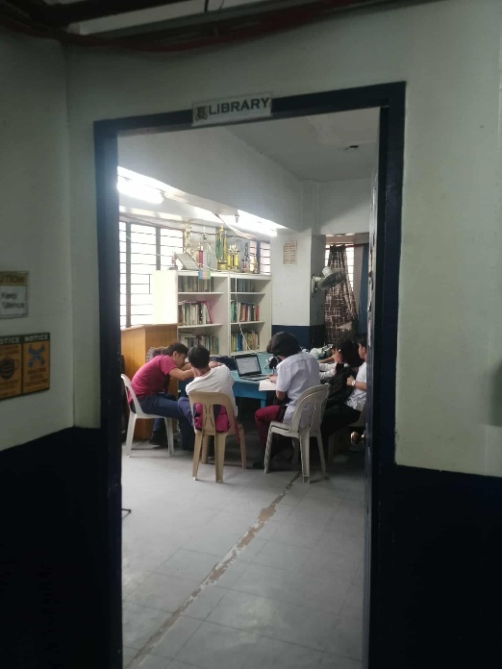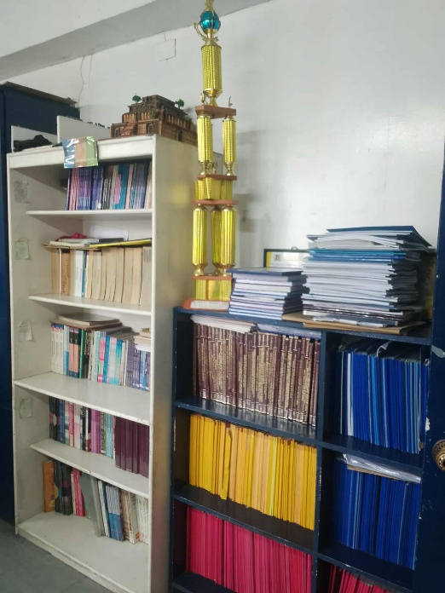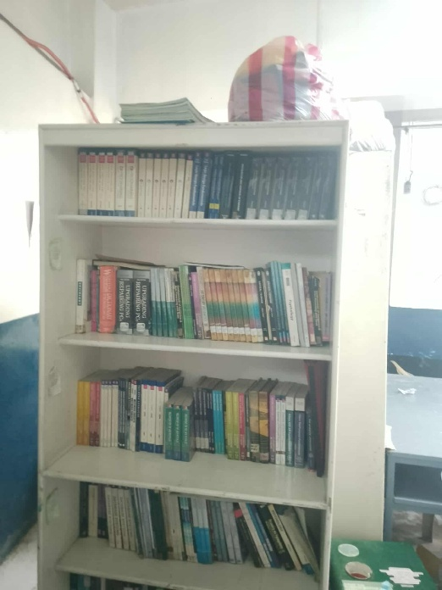

**Contact Information**

Client: Datamex College of Saint Adeline Valenzuela Branch

Address: Gotaco, 11, Gotaco Building 2, MacArthur Highway, Marulas, R-9, Valenzuela, 1440 Metro Manila

**About Datamex College of Saint Adeline**

Datamex College of Saint Adeline is an educational institution offering both Senior High School and College programs. It has multiple branches across Metro Manila, with a focus on innovation and technology. The institution aims to provide quality education and instill nationalistic values in its students.

**PROJECT SCOPE**

**Deliverables and Outcomes**

* Library Management System
* Admin dashboard for the Librarian(s)
* Available books catalog
* Borrowing and returning process

**Inclusions**

* Librarian/Admin account
* Borrowed book tracking
* Lists of available books

**Exclusions**

* Digital copy of books(e-book)
* The system is only for Valenzuela Branch
* Student access
* Book filtering by course/strands

**Assumptions and Constraints**

* The system will be hosted on school owned servers
* New books will be added to the system by the librarian

**PROJECT APPROACH**

**Overview**   
 This project aims to develop a Library Management System (LMS) that simplifies and digitizes core operations, cataloging, borrowing/returning books, and student record management. It will enhance efficiency and accessibility for students and staff.

**Methodologies & Frameworks**

Agile methodology is a pivotal project management approach predominantly applied in software development. It embodies a dynamic process where demands and solutions evolve through the synergistic collaboration of self-organizing, cross-functional teams, and their engaged customers.

The Agile methodology is rooted in a set of principles (see next chapter) valuing adaptability and flexibility. Agile stands as a transformative force, enhancing responsiveness to ever-changing business needs.

It empowers teams to deliver tangible progress in incremental, workable increments, fostering a climate of continuous improvement.

**PROJECT TEAM**

**ANTHONY LADIA**

**Role:** Project Manager

**Skills:** Can lead and have an adequate amount of knowledge in different programming languages to guide our team.

**Credentials:** Became a leader/project manager for multiple projects and successfully managed every single one.

**RJHAY JUNSAY**

**Role:** Backend Programmer

**Skills:** Specializes in Database, Functions, Scripts and Backend Programming.

**Credentials:** Worked as a programmer on multiple projects and successfully completed every one of them.

**UVERT MARABE**

**Role:** Front End Developer

**Skills:** specialize in programming in making visual design in

Visual basics 10

**Credentials:** Designed multiple projects creating functional and pleasing system.

**ACEZZEL ANN HONDRADO**

**Role:** System Analyst

**Skills:** gather user requirements, analyze system functionality, and assist in designing user-friendly workflows.

**Credentials:** Has knowledge in system functions and can provide input for planning and development.

**PROJECT TIMELINE**

|  |  |  |
| --- | --- | --- |
| **WEEK** | **PHASE** | **ACTIVITIES** |
| Weeks 1-2 | Planning and Research | Conduct a needs assessment and gather system requirements through interviews and observation. Define project scope, objectives, and target users. |
| Weeks 3-4 | Designing the System | Create form layouts and UI mockups using Visual basic 10. Design the SQL Server database schema and plan system modules and workflows. |
| Weeks 5-8 | System Development | Develop the application using VB.NET. Implement features such as book search, borrow/return logic, availability tracking, and image handling. |
| Weeks 9-10 | Testing and Fixing Issues | Perform unit and integration testing. Fix bugs, validate database operations, and improve UI responsiveness and error handling. |
| Week 11 | Deployment Setup | Package the application with the database for offline use. Prepare user documentation and conduct a pilot run on school lab computers. |
| Week 12 | Documentation and Finalization | In the final week, finalize complete all project documents, including the user guide. |

**Key Activities & Milestones**

| **Phase** | **Week(s)** | **Details** |
| --- | --- | --- |
| Requirements Gathering | Week 1–2 | Interviews and stakeholder feedback |
| Design & Wireframes | Week 3–4 | UI/UX mockups and design approval |
| Development | Week 5–7 | Frontend and backend coding |
| Testing & Integration | Week 8 | Functional testing and bug fixing |
| Finalization & Delivery | Week 9–10 | Deployment, documentation, presentation |

**Critical Path**:

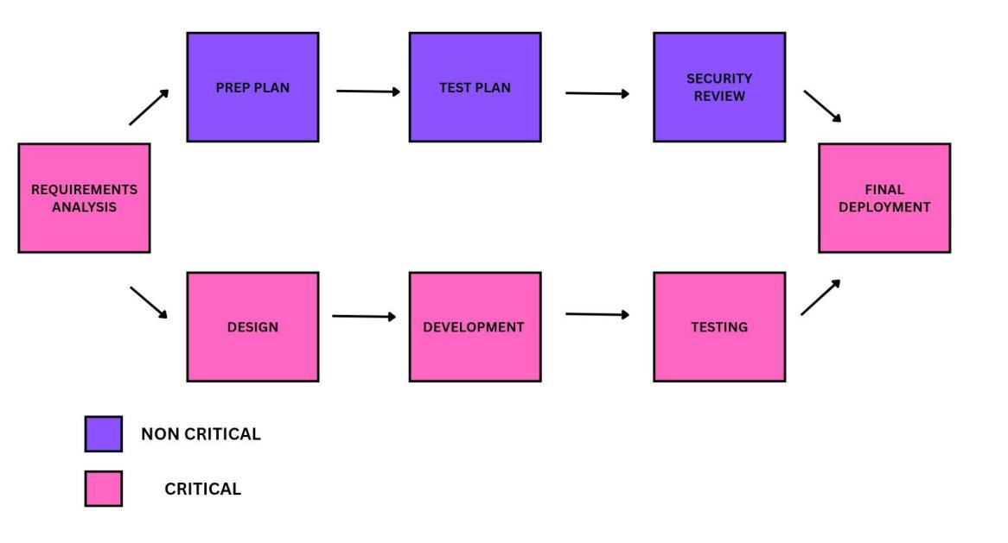

**Critical Path**

|  |  |
| --- | --- |
| **Paths** | **Duration** |
| Requirements Analysis | 1 week |
| Design and War frame | 1 week |
| Development and Coding | 2 weeks |
| Testing | 1 week |
| Deployment | 1 week |

**Non-Critical Path**

|  |  |
| --- | --- |
| **Paths** | **Duration** |
| Preparation Plan | 2 weeks |
| Test Plan | 1 week |
| Security Reviews | 1 week |

**PROJECT RESOURCES**

**Hardware Resources**

* **PC**: Local hosting of the website and the database.

**Software Resources**

* **Website's Front End**: Built using VB.NET Windows Forms, providing a user-friendly desktop interface for the librarian.
* **Backend Database (MySQL)**: SQL Server used to manage book inventory.

**RISK MANAGEMENT**

**Potential Risks**

|  |  |  |  |
| --- | --- | --- | --- |
| **Risk** | **Level** | **Addressing Risks** | **Level** |
| Implement a simple backup strategy by creating daily copies of the database using SQL Server’s backup feature. Store backups in multiple locations such as local folders and external drives. Regularly test the restoration process to ensure data recovery is reliable in case of system failure. | **Low** | Strong password policies and user authentication, regular security updates and patches and access level restrictions based on user roles. | **Low** |
| Quick system restoration procedures and manual backup processes for critical operations. | **Low** | Regular code reviews and quality assurance | **Low** |
| Server crashes, network failures, power outages | **Medium** | Realistic timeline estimation with buffer periods and regular progress monitoring and milestone tracking. | **Low** |
| Schedule Delays | **Medium** | Software bugs/glitches. | **Medium** |
| Database corruption, hardware failure, or accidental deletion | **High** | Unauthorized access to student/patron data. | **High** |

**COMMUNICATION PLAN**

**Communication Management**

Document project progress and decisions for accountability and ensure timely, accurate, and relevant information flow among all stakeholders.

**Key Stakeholders and their Communication Preferences**

**Head Librarian**

Primary end user, requirements owner

Channel: In-person meetings, email, phone calls

**IT Coordinator**

Technical support, system maintenance

Channel: Email, instant messaging, video calls

**PROJECT GOVERNANCE**

* Provides overall direction for the project, ensuring goals and objectives are met effectively.
* Manages schedules, milestones, and deliverables to maintain progress and timely completion.
* Coordinates with stakeholders to gather feedback, address requirements, and ensure transparency.
* Offers technical guidance while ensuring database stability and overall system reliability.
* Oversees quality assurance, risk mitigation, and continuous improvements for long-term success.

**APPENDIX**

INTERQUALITY. (2024). AGILE METHODOLOGY. Interqualitybg.com.

Laoyan, S. (2025, February 20). What is agile methodology? (A beginner’s guide). Asana.

Dinnie Muslihat. (2018, March 2). Agile Methodology: An Overview. Zenkit; Zenkit.